# Design Craft Cube Software

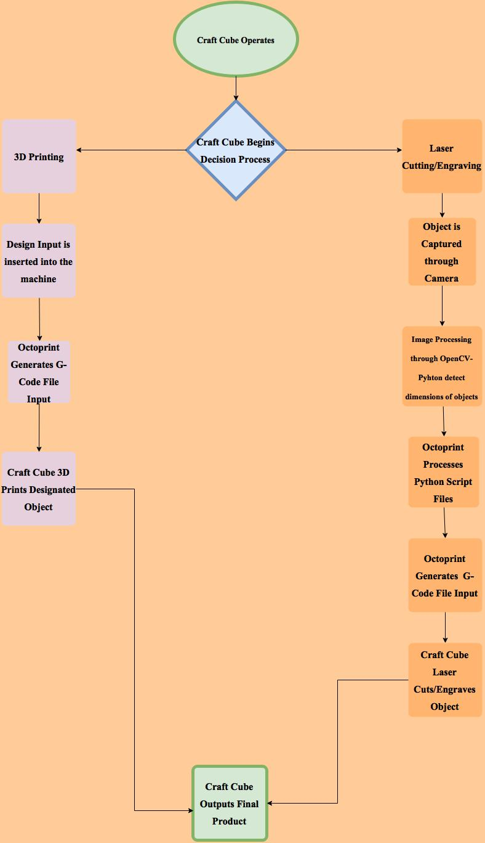

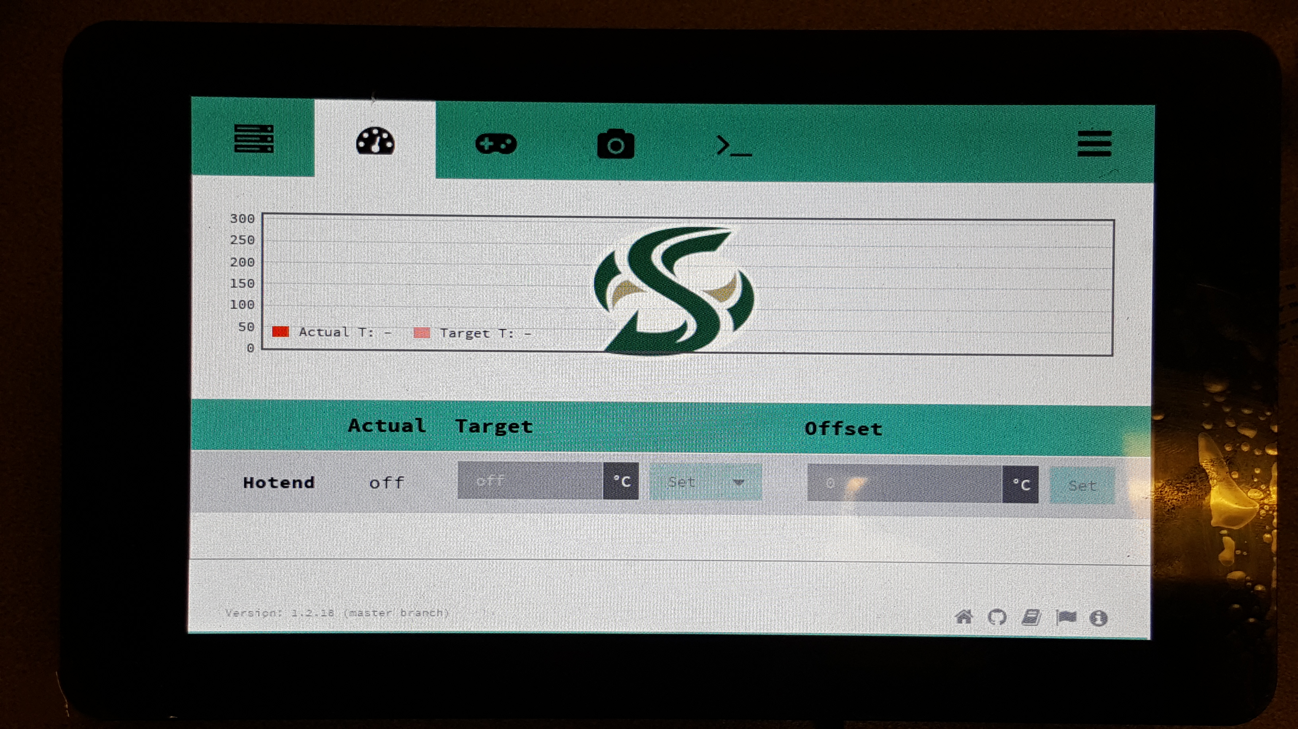

**Craft Cube is a low cost 2 in 1 CNC machine utilizing a user-friendly operating system.**

3D Model Management System

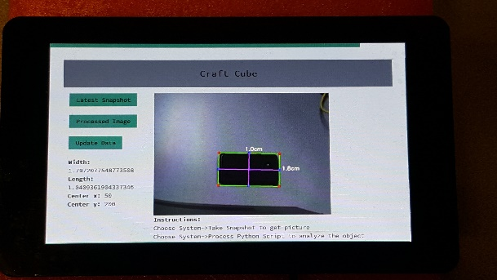

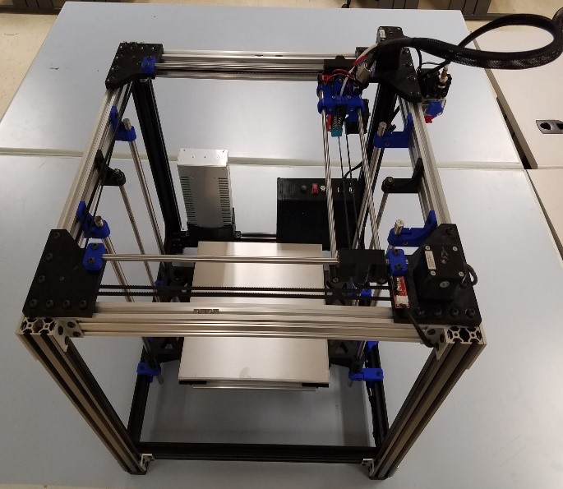

Flowchart

Detection Camera